Ethical and Environmental Analysis

Year: 2023 Semester: Spring Team: 3 Project: Rigged Card Shuffler

Creation Date: Apr 7, 2023 Last Modified: Apr 8, 2023

Author: Brian Lee Email: lee3174@purdue.edu

Assignment Evaluation:

|  |  |  |  |  |
| --- | --- | --- | --- | --- |
| **Item** | **Score (0-5)** | **Weight** | **Points** | **Notes** |
| **Assignment-Specific Items** | | | | |
| **Environmental Impact** |  | x6 |  |  |
| **Ethical Challenges** |  | x6 |  |  |
| **Writing-Specific Items** | | | | |
| **Spelling and Grammar** |  | x2 |  |  |
| **Formatting and Citations** |  | x1 |  |  |
| **Figures and Graphs** |  | x2 |  |  |
| **Technical Writing Style** |  | x3 |  |  |
| **Total Score** |  | | |  |

5: Excellent 4: Good 3: Acceptable 2: Poor 1: Very Poor 0: Not attempted

Comments:

1. Environmental Impact Analysis

While it may not seem obvious at first inspection, the Rigger Card Shuffler (RCS) in its current design state has a significant environmental impact at every stage of its life cycle. This impact is contributed to by many factors, and thus no view of it is complete without investigating all of these aspects, including the device’s selected materials and components used, its manufacturing process, its limited intended use case, its power consumption, and its questionable longevity and maintainability.

Currently, many parts in the RCS are 3D printed using polylactic acid, including the card wheel, card wheel housing, card wheel hopper, motor mounts, axle coupling mechanisms, and various other components. This material is preferable as it is both compostable and recyclable [1], which is not the case with some other plastics options such as ABS. As such, this material choice should not be altered moving forward.

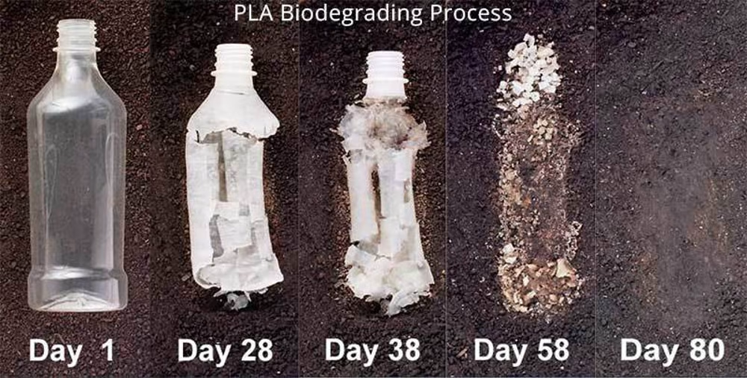

Figure 1: The degradation process of composted PLA [1].

Another factor to consider when discussing the myriad of 3D printed components in the RCS is the environmental impact of the manufacturing process. Devices like 3D printers consume a substantial amount of power. In fact, the average 3D printer can use up to 300 watts per hour [2], and all of the parts in the RCS collectively take days of printing time. Because of this consideration, in order to reduce power consumption and thus environmental impact, a less energy-intensive manufacturing process, like casting plastic with a mold, should be explored.

The case of the RCS is currently made from plywood, which has mixed environmental impact. Obviously, because wood is made from trees, the use of plywood can contribute to phenomena like deforestation. Furthermore, because plywood utilizes synthetic glues, it is not considered biodegradable [3]. Plywood, however, can reduce wood waste as it utilizes parts of a tree that may not be able to be used for other purposes. Therefore, plywood can be considered a reasonably sustainable option, especially when used for long periods of time. To leverage this fact, future designs of the RCS must prioritize increasing the product’s life-span to comparatively decrease the environmental impact of the use of plywood and other materials.

Of course, the RCS also contains many electronic components, from the microcontroller to the LED screen. Of course, these components are not biodegradable. Unfortunately, less than 25% of electronic components that reach the end of their life cycle are recycled in the United States [4]. As such, steps must be taken to ensure that this does not occur for the RCS. For example, the device can be labeled with a request that it be delivered to an electronics recycling center when it no longer functions properly instead of sending it to a landfill.

The manufacturing impact of all of the electronic components must also be acknowledged. For instance, ultrapure water is used in the manufacturing of silicon wafers. From factors like this, it is estimated that the production of a single silicon wafer can emit the equivalent of 350 kilograms of CO2 [5]. Because of this immense environmental impact, care should be taken to use just as many electrical components as necessary, and no more. Future design efforts should specifically reexamine each component and determine whether it is actually necessary for device functionality, and remove any components that are not necessary to reduce manufacturing emissions.

Another factor to consider is the limited use case of the RCS. Because it currently only has one true intended use (to provide a controlled shuffle for entertainment purposes), and that use case does not come up regularly in an average person’s day-to-day life, it is an incredible waste of resources. Thus, future designs should work to officially support and encourage other use cases, such as fair shuffles and assisted game-playing. By providing this additional functionality, more use can be derived from the material cost of the RCS, and thus lessen its overall environmental impact.

Current estimates show that the RCS may use up to 60 watts of power during operation. This is comparable to the power usage of a laptop computer, which while it is not outrageous, is not an insignificant amount either. Future designs must then strive to optimize the power usage of the RCS in order to reduce this number. For example, instead of using two DC motors for the card extraction rollers, a single-motor system with additional gears should be experimented with.

The maintainability of a device is also very important when it comes to its environmental impact. The more maintainable a device is, the longer it can be used for, and thus the less its overall environmental cost. Currently, the RCS requires very precise placement of many specifically designed parts. This poses a huge obstacle to any end user that would want to make their own replacement parts if one were to break. In fact, the accuracy required for the placement of parts likely precludes an average user from properly installing replacement parts, even if they were able to purchase one. With this in mind, future iterations of the RCS must work towards making parts easily replaceable, standardized, and easy to install.

Should parts become unobtainable, then the failure rate of the device then comes into question. Currently, the RCS has many potential vulnerable points of failure, such as plastic coupling mechanisms and plastic motor mounts. To reduce the chance of a device failure, steps should be taken to heighten the reliability of these individual components by redesigning them or selecting a more durable material (like aluminum or steel). These steps should then make each RCS unit last longer, and thus waste less materials.

1. Ethical Challenges

A complex quagmire of moral and ethical dilemmas is the unavoidable nature of a device that can produce controlled shuffles. In addition to the obvious moral grayness associated with the RCS, the device also consumes a not insignificant amount of power and has many motors, which increases the potential dangers that must be mitigated.

Because the RCS can produce controlled shuffles of playing cards, the subject of gambling must be discussed. First, the device should never be sold to businesses that operate games that are played for stakes and wages, or businesses that own buildings in which such gaming occurs. In addition, a label must be affixed to the device that clearly indicates its ability to perform controlled shuffles, and the user interface should have an obvious indication when such controlled shuffles are occurring. Future design efforts could even include a speaker that will announce that the order of cards being outputted is being manipulated, and a function that disables the device should the speaker be tampered with. The user manual should also warn the user against using the RCS to commit fraud, and should very precisely explain that doing so is illegal and immoral. It should be made very obvious to the user that the device is only to be used for entertainment purposes. The user should also be warned that possessing a device for the purpose of defrauding others may also be illegal in certain jurisdictions.

The RCS consumes a noticeable amount of power, especially the four motors. As such, heat is certainly an issue. Therefore, engineering time must be allocated to stress-testing the device in this context before a single consumer can buy the device. With plastic components holding together much of the internal mechanism of the RCS, melting parts and complete device failure is not an impossibility. In addition to this, the mechanism is housed in wood, which is also a fire hazard. These dangers must be made absolutely clear to the user, and so they should be included in the user manual and on a clearly visible label on the device. In addition, the user should be instructed to never allow the device to operate without supervision, nor should it be left plugged in after use.

Because of the fact that motors are being used, that many parts are moving, and that cards are snapping over the dispensing ramp in the card wheel housing, the operation of the RCS is quite loud. Testing must be performed on the operating noise of the RCS, and if the device produces a noise level that would cause discomfort or injure one’s hearing after prolonged exposure, the device must be redesigned and should not be sold to any consumers.

The RCS is designed for indoor use on a flat surface. Therefore, the user should be very clearly warned by labels and in the user manual against moving the device during operation or using the device outdoors, where the RCS may be exposed to water or wind. Similarly, because the device is not designed to be water resistant, warnings must be provided against spilling water on the device, submerging the device, or otherwise exposing the RCS to water.

Thanks to the wooden case and the numerous metal components inside, the RCS is surprisingly heavy. In fact, a user that lifts the RCS without properly expecting the weight may suffer injury. As such, labels and the manual must warn of the weight of the device and inform users of the need to utilize proper lifting form (i.e. not lifting with the back) when transporting, raising, relocating, or otherwise moving the device.

As previously mentioned, there are many moving components inside the RCS, some of which are moving very quickly and placed very close together. These circumstances thus produce an obvious pinching hazard, especially for a user trying to repair the device or a curious child. While no mechanical parts are exposed to the outside of the case, additional design efforts must be made focusing on ensuring the internals are not easily accessible lest a user’s appendage come in contact with a fast moving part and suffer undue harm. Warnings should be provided that the device should never be opened nor should its parts be serviced when it is plugged in.

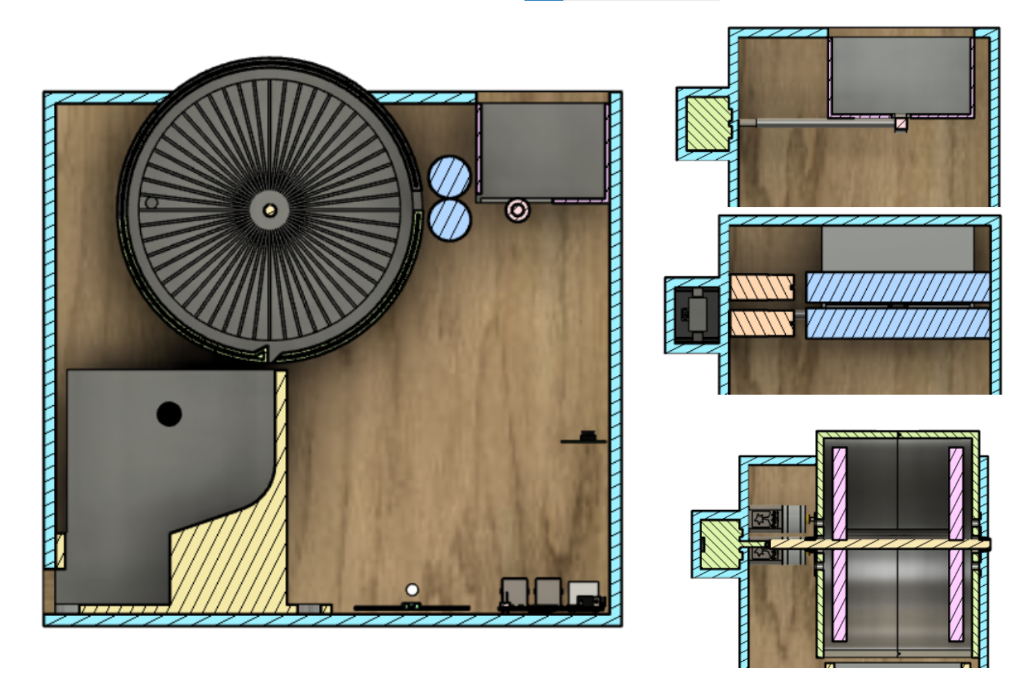

**Figure 2.** Diagram of the various motors and moving mechanisms inside the Rigged Card Shuffler. These parts must be rigorously tested to ensure complete safety for users.

Furthermore, rigorous testing should be performed to ensure that the case can withstand the forces from the fast moving internal parts such that the device does not collapse upon itself or send parts flying away at high speeds, either of which may cause considerable harm to users.

3.0 Sources Cited

[1] Griffin, Melanie. (2023, January 11). *Is PLA Recyclable?* [Online]. Available: <https://all3dp.com/2/is-pla-recyclable/>

[2] Mhatre, Nachiket. (2021, August 28). *How to Significantly Reduce Your 3D Printing Energy Bill.* [Online]. Available: <https://makeuseof.com/make-your-3d-printer-power-efficient-and-reduce-energy-bill>

[3] Nguyen, Quynh. *How Sustainable Is Plywood? Here Are the Facts.* [Online]. Available: <https://impactful.ninja/how-sustainable-is-plywood/>

[4] Semuels, Alana. *The World Has an E-Waste Problem*. [Online]. Available: <https://time.com/5594380/world-electronic-waste-problem/>

[5] Bardon, Marie Garcia. *The environmental footprint of logic CMOS technologies.* [Online]. Available: <https://www.imec-int.com/en/articles/environmental-footprint-logic-cmos-technologies>